Junjun Huang

Final Project Deliverable A

* URL of your site
  + http://ectweb.cs.depaul.edu/jhuang50/ect436/final
* Brief description of the value of your Web site
  + Simple CMS
* Functions you plan to implement
  + Three-level Categories
  + Article
  + User Management
  + Advertising

• Describe the information structure using a site map (i.e. how many web pages you plan to write? How are they linked together?)

* + MVC – for 4 functions about 12 pages
  + A database class, An authority class
  + Site map
    - Index.php
      * Admin/ User(folder)
        + M/V/C
      * Class(folder)
        + Database.php
        + Authority.php
      * Categories(folder)
        + M/V/C
      * Article(folder))
        + M/V/C
      * Advertising (folder)
        + M/V/C

• Layout design

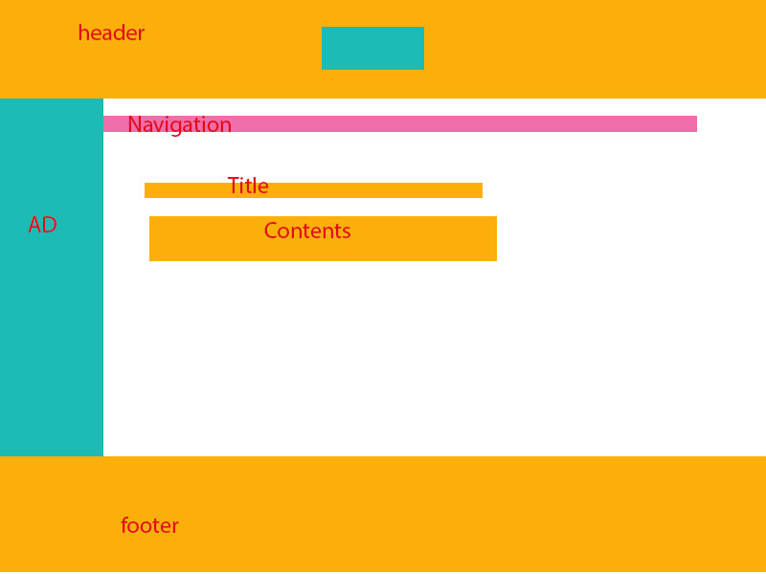

• Plan of work (i.e. when and how to gather information? When and how to write each page?)

* + July4-5 weekend to get it done.